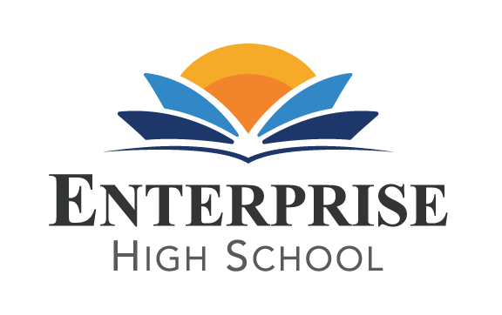
www.//enterprisehs.org
Legal Public Notice
School Board Notice is hereby given that on
Monday, November 20th, 2017 at 5:00 pm
Enterprise High School will hold a Public Board Meeting at
Enterprise High School
located at 2461 McMullen Booth Road Clearwater, FL 33759
NOTICE OF SPECIAL GOVERNING BOARD MEETING FOR PINELLAS EDUCATION ORGANIZATION, INC., D/B/A ENTERPRISE HIGH SCHOOL ON AUGUST 14, 2017
- A SPECIAL GOVERNING BOARD MEETING WILL BE HELD ON NOVEMBER 20th, 2017 UTILIZING COMMUNICATIONS MEDIA TECHNOLOGY (“CMT”). THE CMT USED WILL BE THE FOLLOWING CONFERENCE CALL-IN NUMBER: 712-432-0220 and Enter PIN _6381608___ followed by pound (#).
INTERESTED PERSONS MAY ATTEND THIS MEETING IN-PERSON AT THE FOLLOWING ADDRESS: 2461 MCMULLEN BOOTH ROAD, BUILDING B, CLEARWATER, FL 33759. FOR MORE INFORMATION ABOUT THIS MEETING OR TO PROVIDE INFORMATION TO BE CONSIDERED AT THIS MEETING, PLEASE CONTACT Donna Hulbert at donna.hulbert@enterprisehs.org . THE MEETING WILL INCLUDE DISCUSSION REGARDING MATTERS PERTAINING TO ENTERPRISE HIGH SCHOOL.

The subject of the call is the November 20th Board Meeting. The purpose of this meeting is to consider various administrative matters, finance committee matters and address any general business that may properly come before the Board of Directors.

