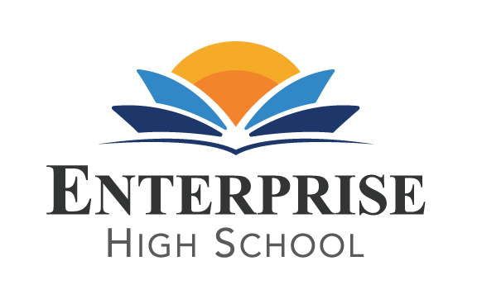
Enterprise High School
2461 McMullen Booth Road Clearwater, FL 33759
Board of Directors Meeting Monday, November 9th, 2022, at 5:30 PM EST

EHS BOARD MEETING
Please join my meeting from your computer, tablet or smartphone. https://www.gotomeet.me/DelvinVick
You can also dial in using your phone. United States: +1 (872) 240-3212
Access Code: 828-964-493

BOARD AGENDA
- Public Sign –In
- Call to Order
- Welcome and Introductions
4. Public Comment
5. Board Action Items and Discussions:
A. Motion to determine next steps with San Jose Schools Support.
B. Motion to determine next steps with Tampa Bay Educational Consultant, LLC.
C. Share update with TSIA dollars.
D. Change date of next meeting from 12/5 to the following week of 12/12/22.

- Announcements: Graduation Ceremony is on 12/15at 7:00 pm at Countryside High School.

- Adjournment

