2023-2024 Title I Parent and Family Engagement Plan
School Name: Enterprise High School
Please use the Comprehensive Needs Assessment Data and any other family engagement data to complete the following:

School’s Mission Statement: To Reach the Heart, Educate the Mind, And Graduate the Whole Student.

Measurable Outcomes: Enterprise has six annual goals based around student attendance, course completions, graduation rates, and reading and math proficiency.

Goal 1: Enterprise will achieve a 4-year federal graduation rate of 38% (Baseline: 59.3%)
Goal 2: Enterprise will achieve a 4-year federal graduation rate among the African American cohort of 26%
(Baseline 47.5%)
Goal 3: 68% of students enrolled for both Survey 2 and 3 will earn a minimum of 4 credits (baseline 70%)
Goal 4: ELA or Concordant Score passage among students enrolled in Surveys 2 and 3 will be 40% or higher
(Baseline: 46%)
Goal 5: Algebra I EOC or concordant passage among students enrolled in Surveys 2 and3 will be 50% or higher
(Baseline: 58%)
Goal 6: Enterprise will have an average attendance rate of 44% or higher (Baseline: 41%)

Building Capacity of Families
Describe how the school will implement activities that will build the capacity for strong parent and family activities, in order to ensure effective involvement of parents and to support a partnership among the school involved, parents, the community to improve student academic achievement [Section 1118(e)]. Describe the actions the school will take to provide materials and training to help parents work with their child to improve their child s academic achievement [Section 1118(e)(2)]. Include information on how the school will provide other reasonable support for parental involvement activities under Section 1118 as parents may request [Section 1118(e)(14)].

Based on the data from the Comprehensive Needs Assessment, please complete the Family Engagement Planning Sheet
for an upcoming event that will be directly tied to the measurable outcome(s) above.

Staff Professional Development related to Family Engagement
Describe the professional development activities the school will provide to educate the teachers, pupil services personnel, principals, and other staff in how to reach out to, communicate with, and work with parents as equal partners, in the value and utility of contributions of parents, and in how to implement and coordinate parent programs, and build ties between parents and schools [Section 1118(e)(3)]

How will school leadership actively build teacher and staff capacity related ongoing family engagement connected to academic goals?

Parent Engagement Strategies was one of our higher PD requests from staff. We are already undertaking this work. Stakeholder engagement (including parents) is a large part of the Cognia accreditation process. We started addressing those standards during our summer PD sessions. In addition, we have a guest presenter coming on July 27th to share school culture and parent engagement strategies with our entire staff.

As a dropout prevention school, we’ve had our share of challenges with Parent Engagement. During Spring 2023, we reached out to parents via our school newsletter, inviting them to be part of a series of advisory meetings. So far, only two parents have shown interest.

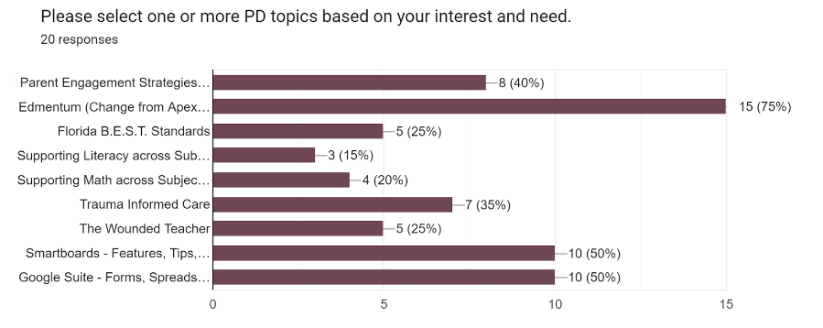

Ongoing surveys and feedback from parents will be part of our 2023-24 internal school goals. While we are great at graduating students, we fall short in getting meaningful feedback from stakeholders. Our Parent Survey results continue to be favorable, but the question responses haven’t yielded actionable feedback.

Title I Annual Parent Meeting Experience
Each school will convene an annual meeting designed to inform parents of participating children about the schools Title I program, the nature of the Title I program (schoolwide or targeted assistance), school choice, supplemental educational services, and the rights of parents. [Section 1118(c)(1)].
How will you get recorded feedback from parents about the meeting? How will the recorded feedback be used to inform future events?

Enterprise High School hosts two Annual Title I meetings, one in the fall and one in the winter. We do this because our school population shifts after our December graduation ceremony. At this event, we go into a thorough view of our school’s Title I funds and how we use those funds to benefit students and families. During the close of each event, we require parents to submit a brief 5-question survey. The survey seeks feedback on the school’s use of Title I funds and asks if parents have any suggestions. We review the surveys, which have largely reflected that our parents support our use of funds and have no further suggestions.

How will you address barriers to increase attendance and academic support at home?

We had a great deal of success reaching our attendance goal for 22-23 by employing an Attendance Specialist/Family Liaison. For the 2023-24 school year, we plan to further support this role through Title I funds and General budget funds.

How will you get the information home to parents using various modalities who do not attend?

Enterprise High School has a healthy social media following (Facebook & Instagram). We use those channels to communicate with stakeholders. In addition, major school presentations are recorded and uploaded to our school’s YouTube channel. Parents receive updates via School Messenger, eNewsletters, and Flyers.

Communication
Describe how the school will provide parents of participating children the following [Section 1118(c)(4)] • Timely information about the Title I programs [Section 1118(c)(4)(A)]; • Description and explanation of the curriculum at the school, the forms of academic assessment used to measure student progress, and the proficiency levels students are expected to meet [Section 1118(c)(4)(B)]; • If requested by parents, opportunities for regular meetings to formulate suggestions and to participate, as appropriate, in decisions relating to the education of their children[Section 1118(c)(4)(C)]; and • If the schoolwide program plan under Section 1114 (b)(2) is not satisfactory to the parents of participating children, the school will submit the parents comments with the plan that will be made available to the local education agency [Section 1118(c)(5)].
Every family/student at Enterprise High School receives an individual one-on-one orientation that thoroughly describes our educational program and academic supports. In addition, time information is sent via eNewsletter, School Messenger, Progress Reports, teacher-parent emails, Grad Coach contact, our attendance specialist, and via social media.

Flexible Parent Meeting
Describe how the school will offer a flexible number of meetings, such as meetings in the morning or evening, and may provide with Title I funds, transportation, childcare, or home visits, as such services related to parental involvement [Section 1118(c)(2)].
Enterprise HS held two Title I information nights. These events took place after normal workday hours to allow a majority of our parents to attend. Aside from that, EHS maintains an open-door policy. Parents can request a meeting with school administrators and/or team members without a scheduled appointment. We also conduct home visits and neutral site meetings when requested by a parent.

Accessibility
Describe how the school will provide full opportunities for participation in parent and family engagement activities for all parents (including parents with limited English proficiency, disabilities, and migratory children). Include how the school plans to share information related to school and parent programs, meetings, school reports, and other activities in an understandable and uniform format and to the extent practical, in a language parents can understand [Section 1118(e)(5) and 1118(f)].

EHS is purposeful in hiring team members who can fluently speak and communicate in multiple languages. Native Spanish speakers are our second highest demographic group. All pertinent school communication is translated and sent along with the English version. We also make Spanish translation available for parents who do not speak English fluently.

