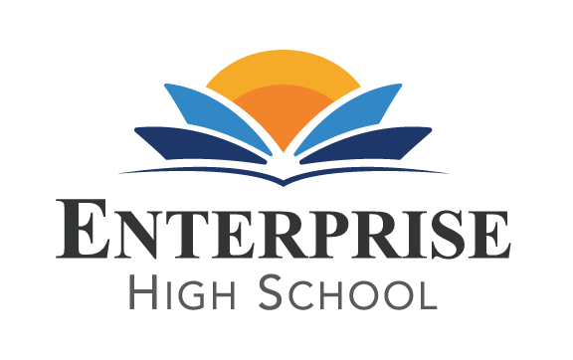
Enterprise High School
2461 McMullen Booth Road Clearwater, FL 33759
Board of Directors Meeting Monday, April 4, 2022 at 5:30 PM EST
Enterprise High School Board Meeting
Please join my meeting from your computer, tablet or smartphone.
https://www.gotomeet.me/DelvinVick
You can also dial in using your phone.
United States: +1 (872) 240-3212
Access Code: 828-964-493

BOARD AGENDA
- Public Sign –In
- Call to Order
- Welcome and Introductions
- Public Comment
- Board Action Items and Discussions:
  - Review and Approve board minutes from February 7th, 2022.
  - Review and Approve financial statements from January and February 2022.
  - Review loan and mortgage information (see highlights of process thus far, regulations of loan and process moving forward).
Approve two board members to sign final mortgage documents when presented.
Approve Resolution as presented by Melissa Gross Arnold, Attorney for loan modification.
  - Review and Approve Summer 2022 Calendar and 22-23 School Year Calendar.
  - Approve one board member to assist school leadership team with property and liability insurance renewals.
  - Approve one board member to assist school leadership with health insurance packages for staff.( April-May)
  - 2 year board training renewal for Jan Barr, Ray Merritt and Dr. Irene Flytzanis by Mid-May and Jacob Montalvo by early October. Information will be sent to each board member by email. Completed packets should be scanned and sent to enterprise@sanjoseschoolssupport.org. or dropped off at school.
  - Discuss continuation of consultant with San Jose Schools. Final Decision can take place at June Board meeting. Current contract ends on June 30th.
  - Review State of the School Report.
- Announcements:
  - Graduation Information

- Adjournment
Next Board Meeting is scheduled for June 6th.

