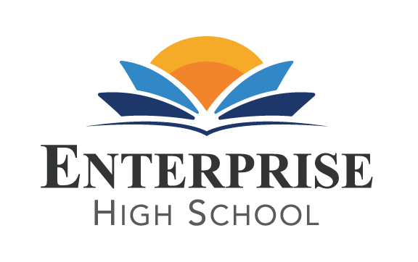
Enterprise High School
2461 McMullen Booth Road Clearwater, FL 33759
Board of Directors Meeting Monday, October 28th, 2021 at 2:00 PM EST
Enterprise High School Board Meeting
Please join my meeting from your computer, tablet or smartphone.
https://www.gotomeet.me/DelvinVick
You can also dial in using your phone.
United States: +1 (872) 240-3212
Access Code: 828-964-493

BOARD AGENDA
- Public Sign –In
- Call to Order
- Welcome and Introductions
- Public Comment
- Board Action Items and Discussions:
  - Review and Approve payment plan presented by Marcus May’s legal team
- Adjournment
Next Board Meeting is scheduled for December 6th, February 7th, April 4th, and June 6th.

