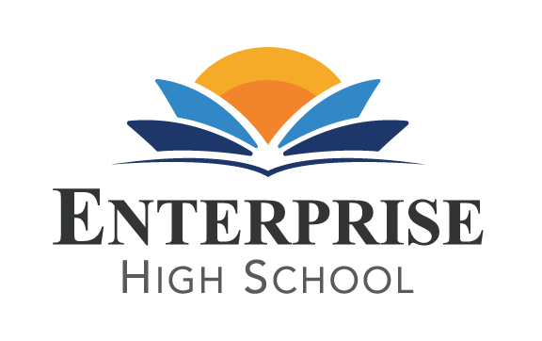
Enterprise High School
2461 McMullen Booth Road Clearwater, FL 33759
Board of Directors Meeting Monday, October 11th, 2021 at 5:30 PM EST
EHS Board Meeting
Mon, October 11th, 2021 5:30 PM - 7:30 PM (EDT)
Please join my meeting from your computer, tablet or smartphone.
https://www.gotomeet.me/DelvinVick
You can also dial in using your phone.
United States: +1 (872) 240-3212
Access Code: 828-964-493

BOARD AGENDA
- Public Sign –In
- Call to Order
- Welcome and Introductions
- Public Comment
- Board Action Items and Discussions: Facilitator
  - Review and Approve August Board Minutes Jan
  - Review and Approve August Financial Statements. Vicki
  - Review Annual Audit from King and Walker Vicki
  - Review and Approve ICP, TSIA and Referendum Plans Vicki and Delvin
  - Review Final Evaluation for 20-21 School Year from PCSB
and new goals for 21-22 sy. Delvin
  - Construction Update Jan, Delvin and Alan
  - Review Pay for Performance Plan Delvin
  - Review administration needs for school Delvin
  - State of the School Report Delvin
- Adjournment Jan
Next Board Meeting is scheduled for December 6th, February 7th, April 4th, and June 6th.
Bank Statements and Funding Grants will be sent to board members in a compressed file folder for your review. (separate attachment in agenda)

